**Exercise 4. Stock status in stock assessment paradigm with multiple hypotheses (Arctic Sardine MU1)**

|  |
| --- |
| **Exercise Goal:** Identify ways to define a single metric of stock status for Arctic Sardine MU1 in a data-rich context when there is more than one model that is an acceptable characterization of the population dynamics. |

|  |
| --- |
| **Exercise Activity:**   1. Given two models that provide an acceptable characterization of the population dynamics, evaluate at least 2 approaches to defining a metric of stock status for Arctic Sardine MU1 and identify the preferred approach. **An appropriate LRP based on discussion/presentations for Exercise 3 can be used for each model** 2. As a group, complete the slides in the Powerpoint File. The last slide will be presented by a group member at the beginning of the workshop tomorrow. Explain:    1. **Candidate approaches** considered, and their pros and cons    2. The **preferred approach and rationale**       1. Any underlying **assumptions** of the preferred approach?    3. Include a **time series plot** of the metric (e.g., ratio of SSB/LRP) that illustrates the stock status over time.    4. Recommend **a status** for the stock.       1. How is **uncertainty** in stock status taken into account, considering the two hypotheses for the equilibrium catch before year 1 of the time series? |

**Background:**

* This Exercise continues using the model from Exercise 3. Assume that prior to year 1 of the time series, there were international fleets fishing Arctic Sardine and the magnitude of those historical catches is unknown. Assume that the key uncertainty for characterizing the dynamics of the fishery is the assumed historical equilibrium catch before year 1 of the time series.
* Two models are fit:
* Model 1: Same as exercise 3 [*equilibrium historical catch = 4kt, stock is relatively unfished in year 1]*
* Model 2: Model 1 but [*equilibrium historical catch = 80kt, stock is initially depleted in year 1]*

**Dataset (for each model):**

* Annual weight-at-age (g), maturity-at-age (proportion mature), and vulnerability-at-age (proportion selected to the fishery) over the historical time period
* Model-estimated spawning stock biomass (*SSB* in kt), recruitment at age 0 (*Rec* in billions), total biomass (*B* in kt), catch (kt), fishing mortality rate (*F*)

**Some options:** (some calculations have been started in the R script)

* Model-based indicator based on one model
* Model-based indicator based on multiple models (mean, weighted mean)
* Empirical indicator (e.g., acoustic index of SSB, relative exploitation rate)

**Candidate Criteria for Best-Practice Indicators and LRPs:**

* Consistent with an objective to avoid serious harm to the stock
* Based on the best available information
* Operationally useful
* Reliably estimated

**Table 1. Data Files for Exercise 4**

|  |  |  |
| --- | --- | --- |
| File Type | File Name | Description |
| Microsoft PowerPoint 2016 - Review 2016 - PCMag UK | BO Group Ex4.pptx | Powerpoint for group exercise and presentation |
| C:\Users\barretttj\AppData\Local\Microsoft\Windows\INetCache\Content.MSO\3B9046F.tmp | ex4.R | R script that imports data with plots and calculations started Use the main LRP folder as your working directory. |
| These files are used in ex4.R but do not need to be opened: | | |
| R (programming language) - Wikipedia | ex4_data.rda | R data object: a list with elements:  WAA = data frame (weight-at-age by year)  MAT = data frame (maturity-at-age by year)  VUL1 = data frame (vulnerability-at-age by year for model 1  VUL2 = data frame (vulnerability-at-age by year for model 2  D1 = data frame (SSB, recruitment, total biomass, catch, F, acoustic index, unfished spawning biomass, steepness, dynamic SSB0 estimates, by year for model 1  D2 = data frame (SSB, recruitment, total biomass, catch, F, acoustic index, unfished spawning biomass, steepness, dynamic SSB0 estimates, by year for model 2 |
| C:\Users\barretttj\AppData\Local\Microsoft\Windows\INetCache\Content.MSO\3B9046F.tmp | functions.R | R script with functions (in main LRP directory) |

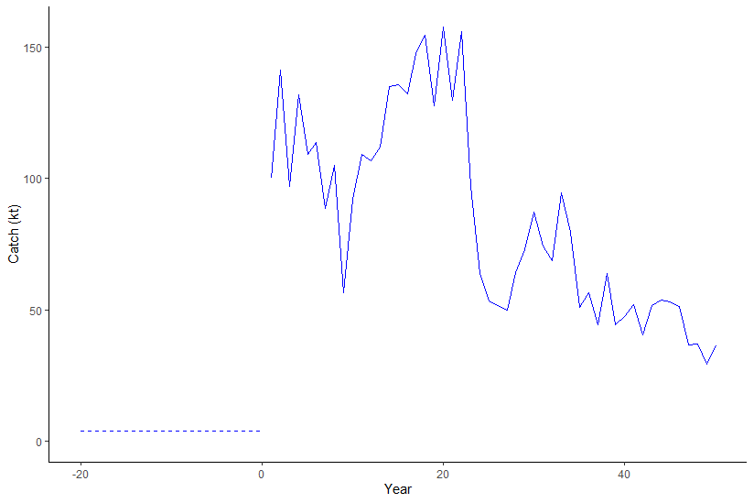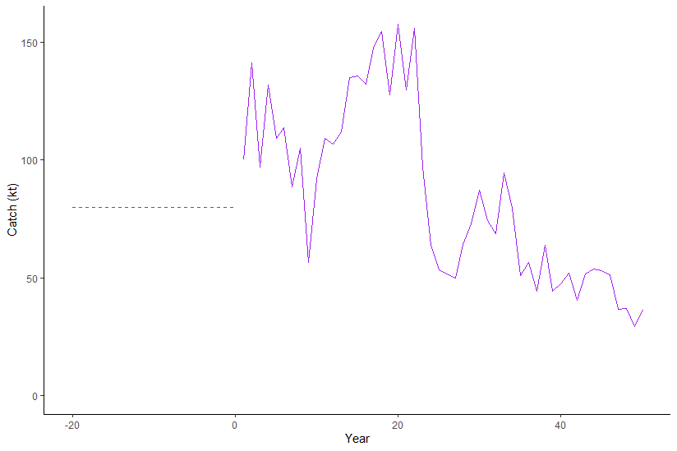

**Figure 1. Historical Catch (Left Panel: Model 1, Right Panel: Model 2)**

*Note: Assumed historical equilibrium catch is plotted as dashed line*

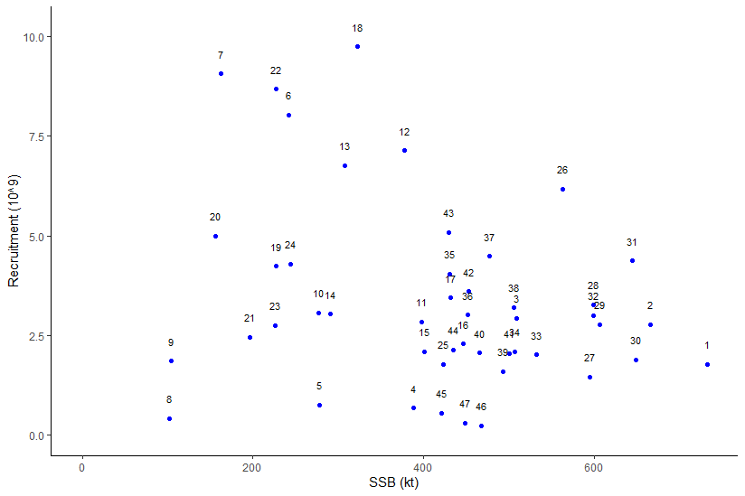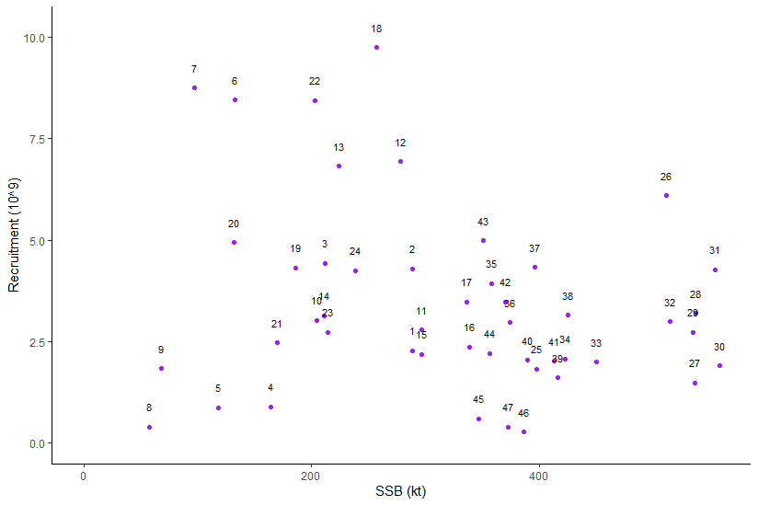

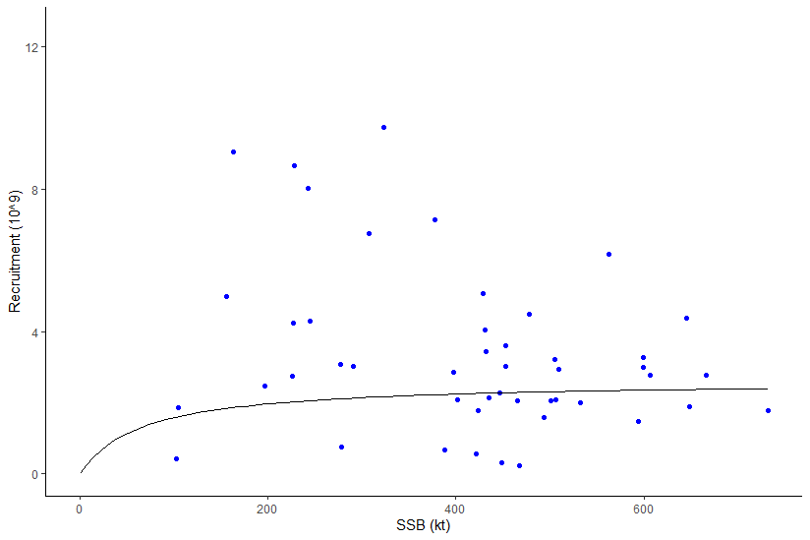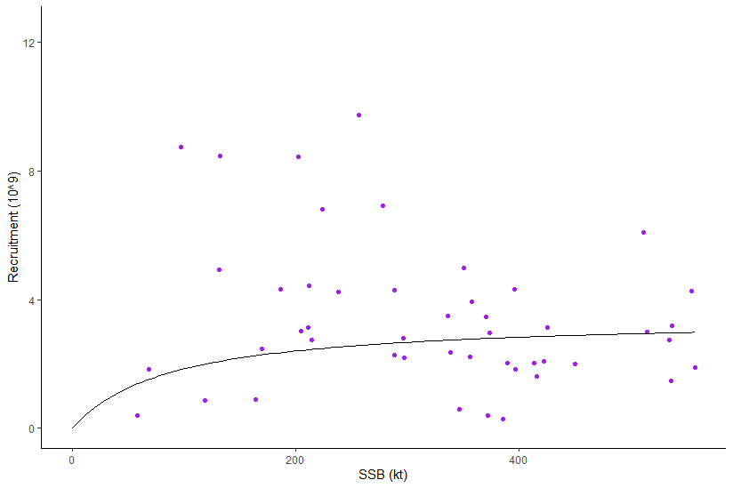

**Figure 2. Estimated Stock Recruitment Pairs and Model Estimated Fits (Left Panel: Model 1, Right Panel: Model 2)**

*Notes:*

*Beverton-Holt stock recruitment relationship, a =* *0.03988293; b = 0.01525998, estimated from assumed h = 0.75 and mean phi0 over the first 5 historical years*

*Beverton-Holt stock recruitment relationship, a =* *0.03988293; b = 0.01157018, estimated from assumed h = 0.75 and mean phi0 over the first 5 historical years*

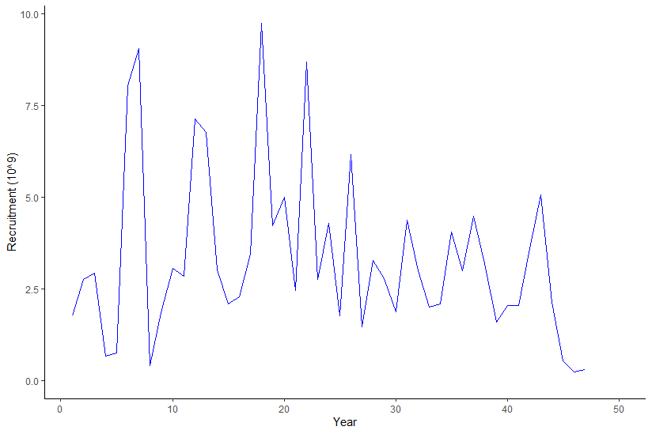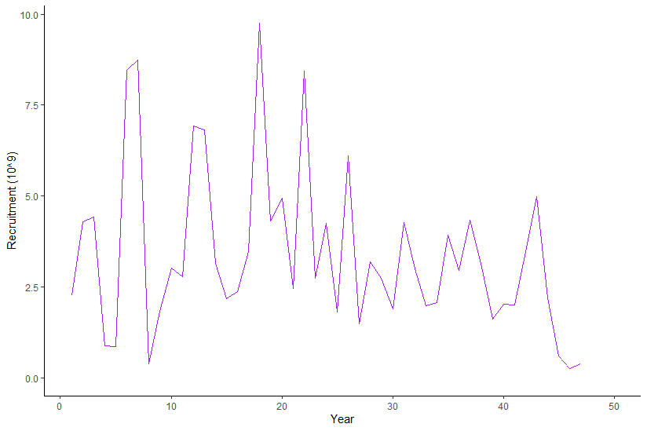

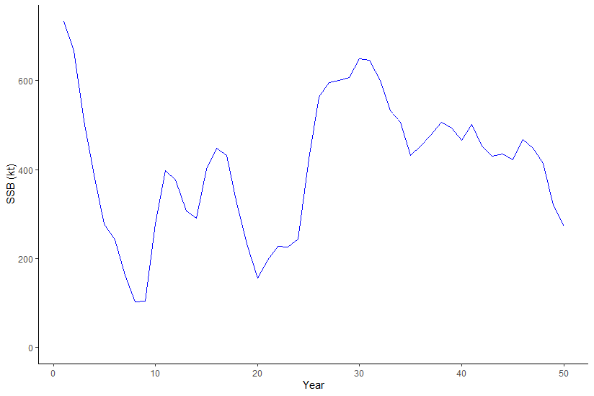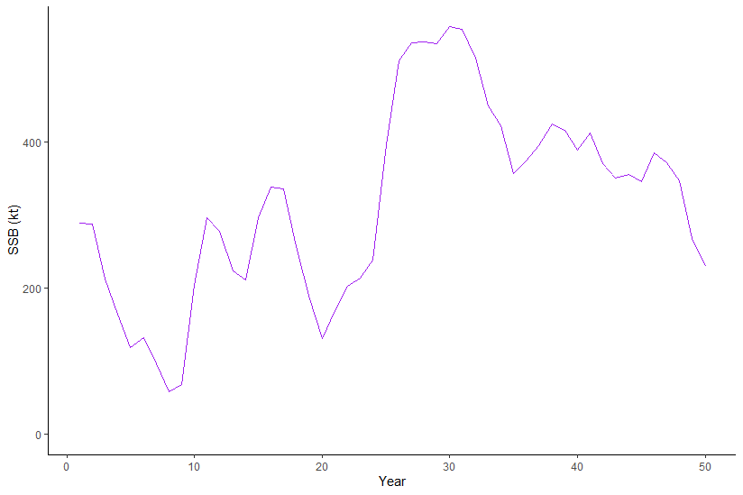

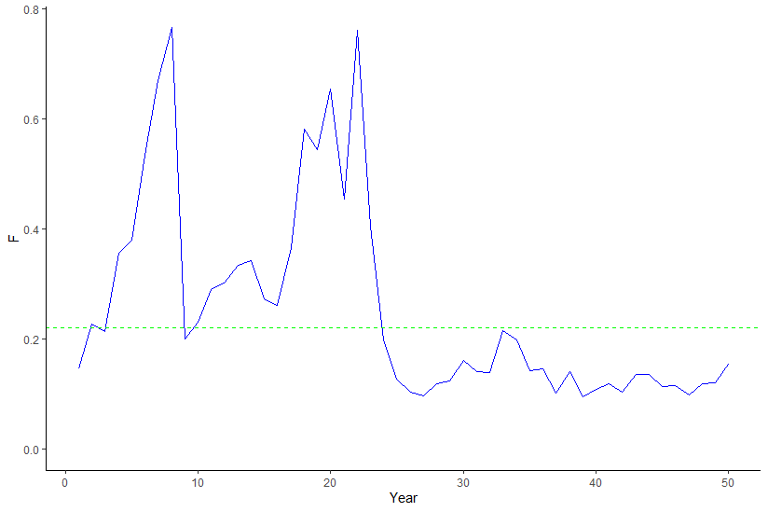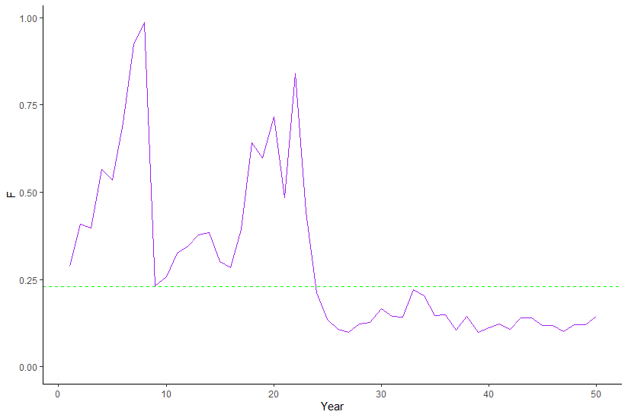

**Figure 3. Time Series Plots for Model Estimated Recruitment, Model Estimated Spawning Stock Biomass, and Model Estimated *F* (Left Panel: Model 1, Right Panel: Model 2)**

*Note: green line = equilibrium FMSY estimated using mean growth, maturity, and vulnerability over last 10 years*